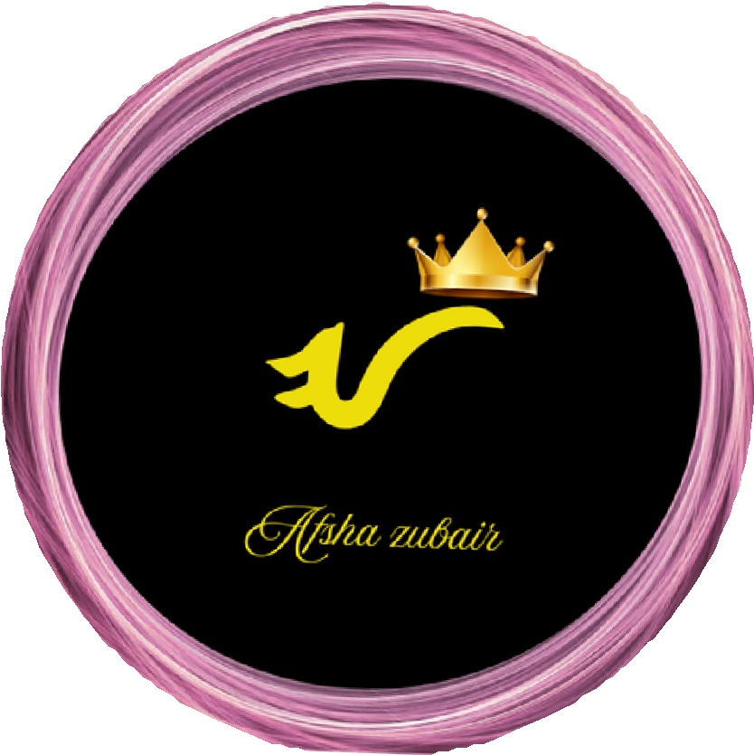

AFSHA ZUBAIR
GRAPHIC DESIGN

EDUCATION

[Matric]

SKILL
Canva Pro ●●●● CapCut Editing ●● Social Media Design ●● Cafe Branding ●● Menu Design ●● Photo Editing ●●●

PROFILE
Self-Taught Creative Graphic Designer and Housewife with passion for digital design.
I create my own brand designs, social media content, and cafe menus using Canva Pro.
I learned design independently and manage my creative work from home with focus,
dedication, and a modern aesthetic sense.

EXPERIENCE

SELF-TAUGHT GRAPHIC DESIGNER & CREATOR
2024 - Present
- Designed and created original social media content, brand templates, and menu designs using Canva Pro
  - Learned graphic design and CapCut independently through self-practice and online resources
- Built a personal portfolio showcasing cafe branding and modern aesthetic designs
- Focused on creating clean, trendy visuals from home
  - Portfolio: afshazubair.my.canva.site
CONTACT

+923220273799


Karachi , Pakistan
 zubairafsha64@gmail.com
 afshazubair.my.canva.site
@Afshazubairofficial

